Exercise 3:  
The objective of this exercise is to create a View object in code using T-SQL.  
**Part A:**• Create a database named Employees.

CREATE DATABASE Employees;

OR

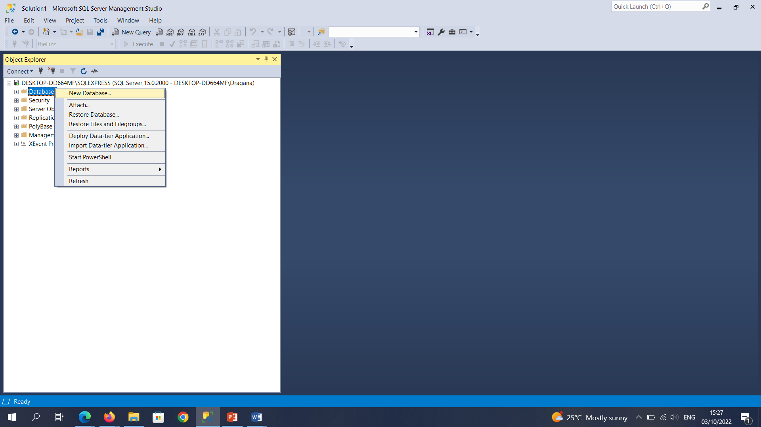

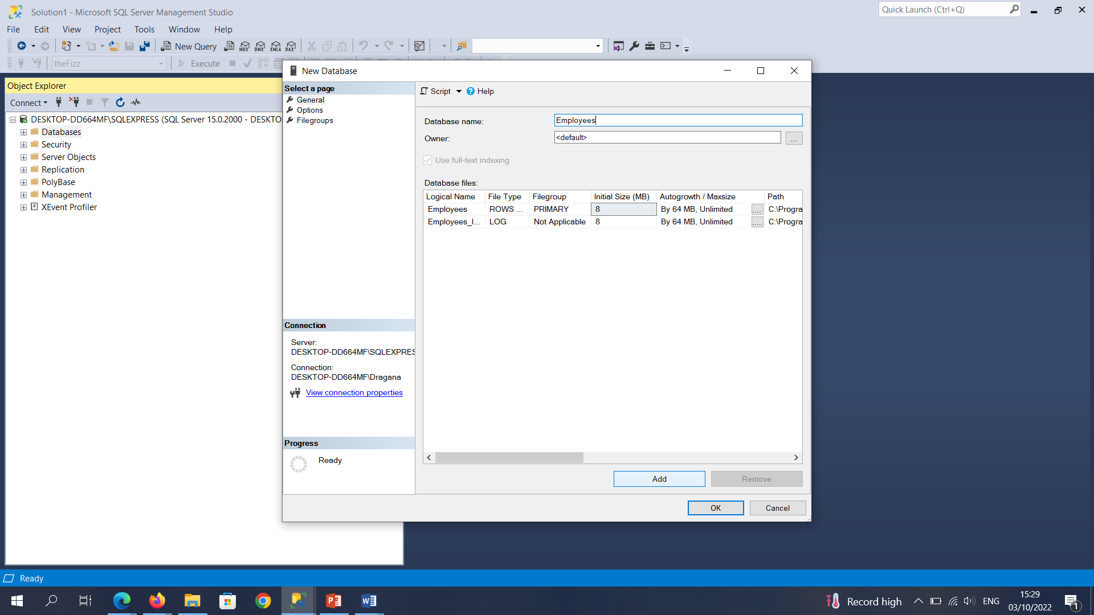

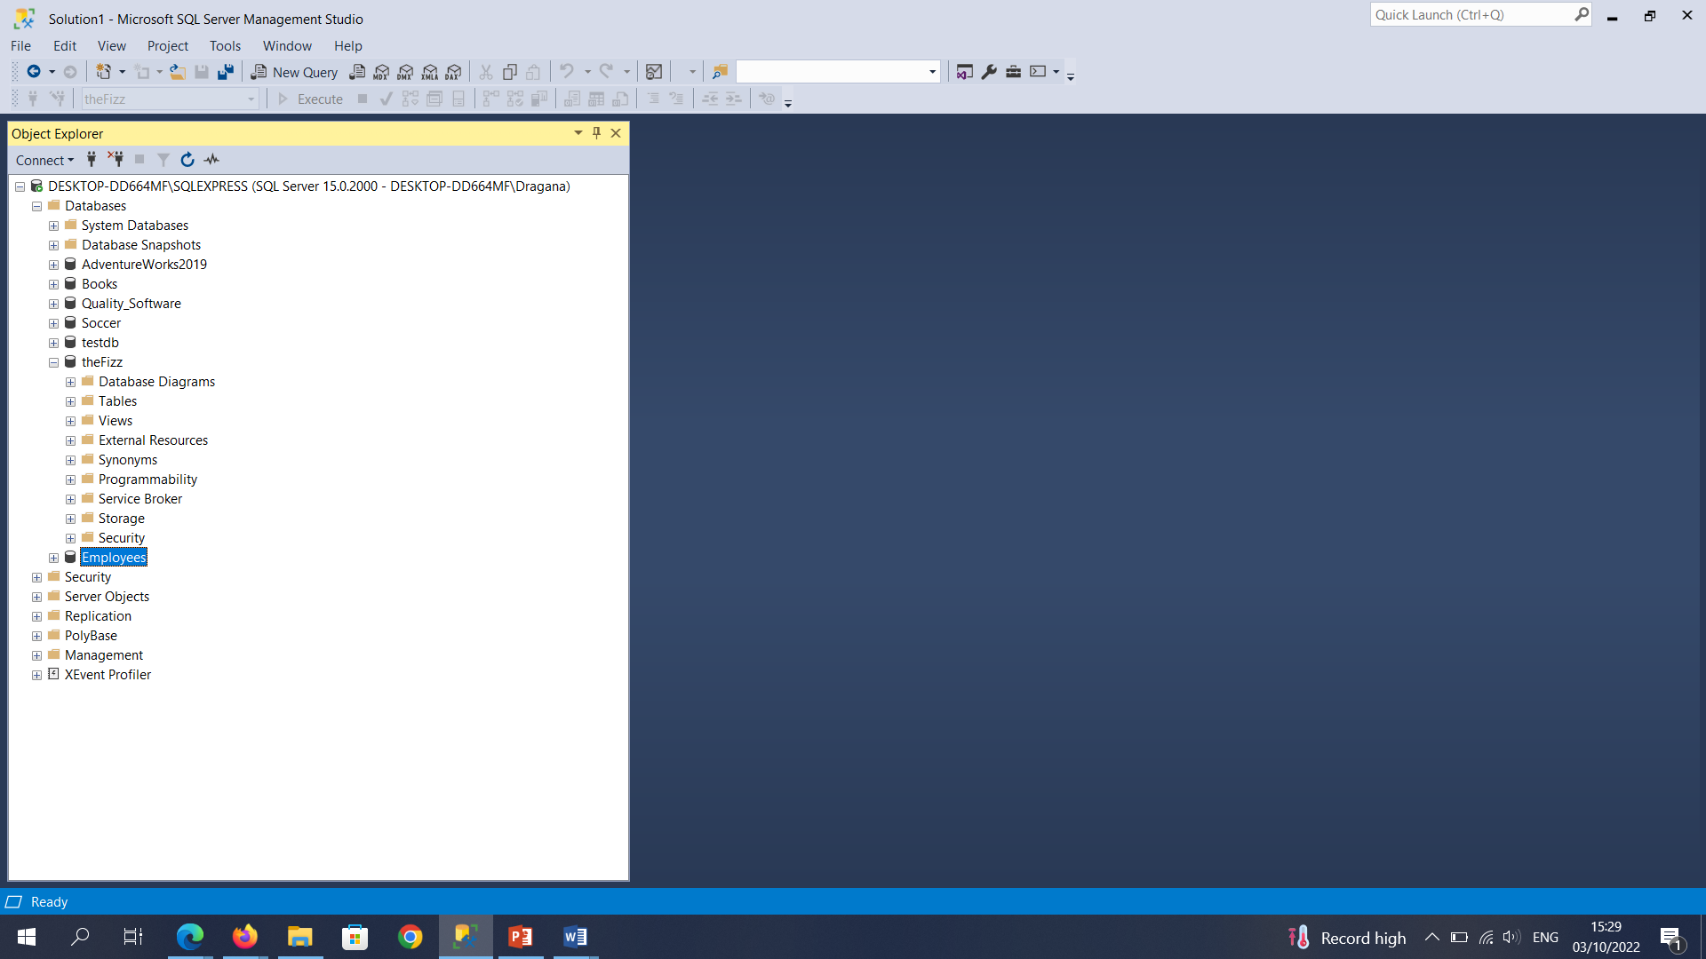

**Part B:**• Create a table named Employee with the following fields.

Field Data Type  
empID [PRIMARY KEY] smallint  
fName varchar(50)  
lName varchar(50)  
age smallint  
empAddress varchar(50)  
empEmail varchar(50)  
empPhoneNo varchar(50)  
salary money

CREATE TABLE Employee (

EmpID smallint PRIMARY KEY,

FName varchar(50),

LName varchar(50),

Age smallint,

EmpAddress varchar(50),

EmpEmail varchar(50),

EmpPhoneNo varchar(50),

Salary money

);

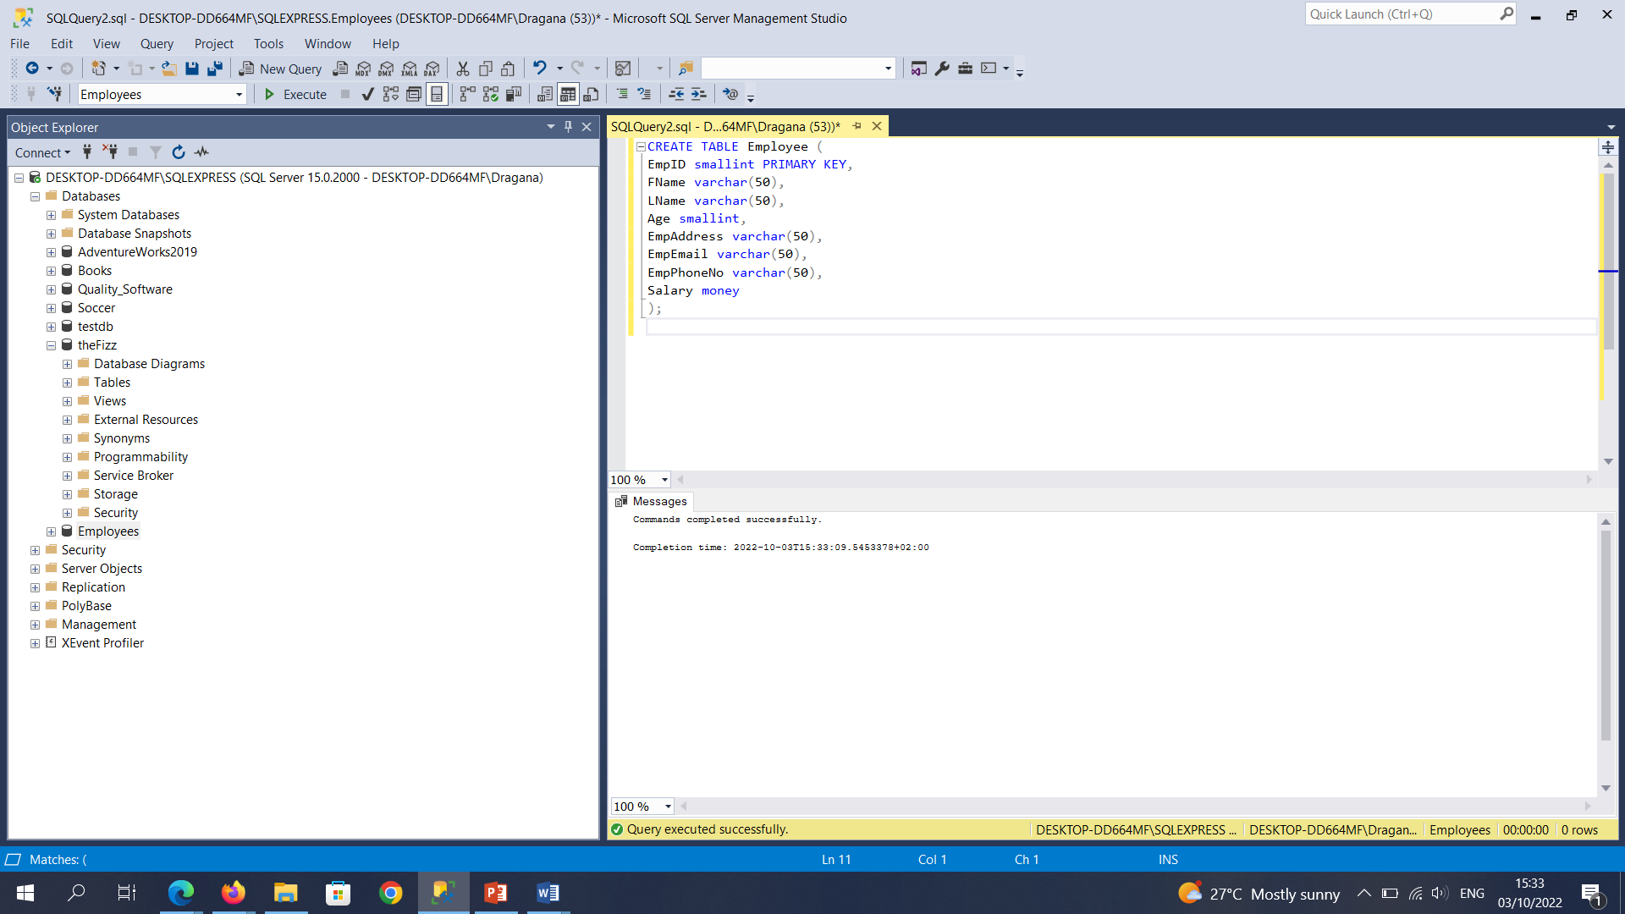

**Part C:**  
• Insert the following records into the table.

Record 1

Field Value  
empID [PRIMARY KEY] 1  
fName Fred  
lName Smith  
age 23  
empAddress 12 High Street, Cork.  
empEmail fsmith@dbconsultants.com  
empPhoneNo 0874527232  
salary 34000

Record 2

Field Value  
empID [PRIMARY KEY] 2  
fName Jane  
lName Taylor  
age 29  
empAddress 10 Low Street, Cork.  
empEmail jtaylor@dbconsultants.com  
empPhoneNo 0876471233  
salary 38000

INSERT INTO Employee (EmpID, FName, LName, Age, EmpAddress, EmpEmail, EmpPhoneNo, Salary)

VALUES (1, 'Fred', 'Smith', 23, '12 High Street, Cork', 'fsmith@dbconsultants.com', '0874527232', 34000);

INSERT INTO Employee (EmpID, FName, LName, Age, EmpAddress, EmpEmail, EmpPhoneNo, Salary)

VALUES (2, 'Jane', 'Taylor', 29, '10 Low Street, Cork', 'jtaylor@dbconsultants.com', '0876471233', 38000);

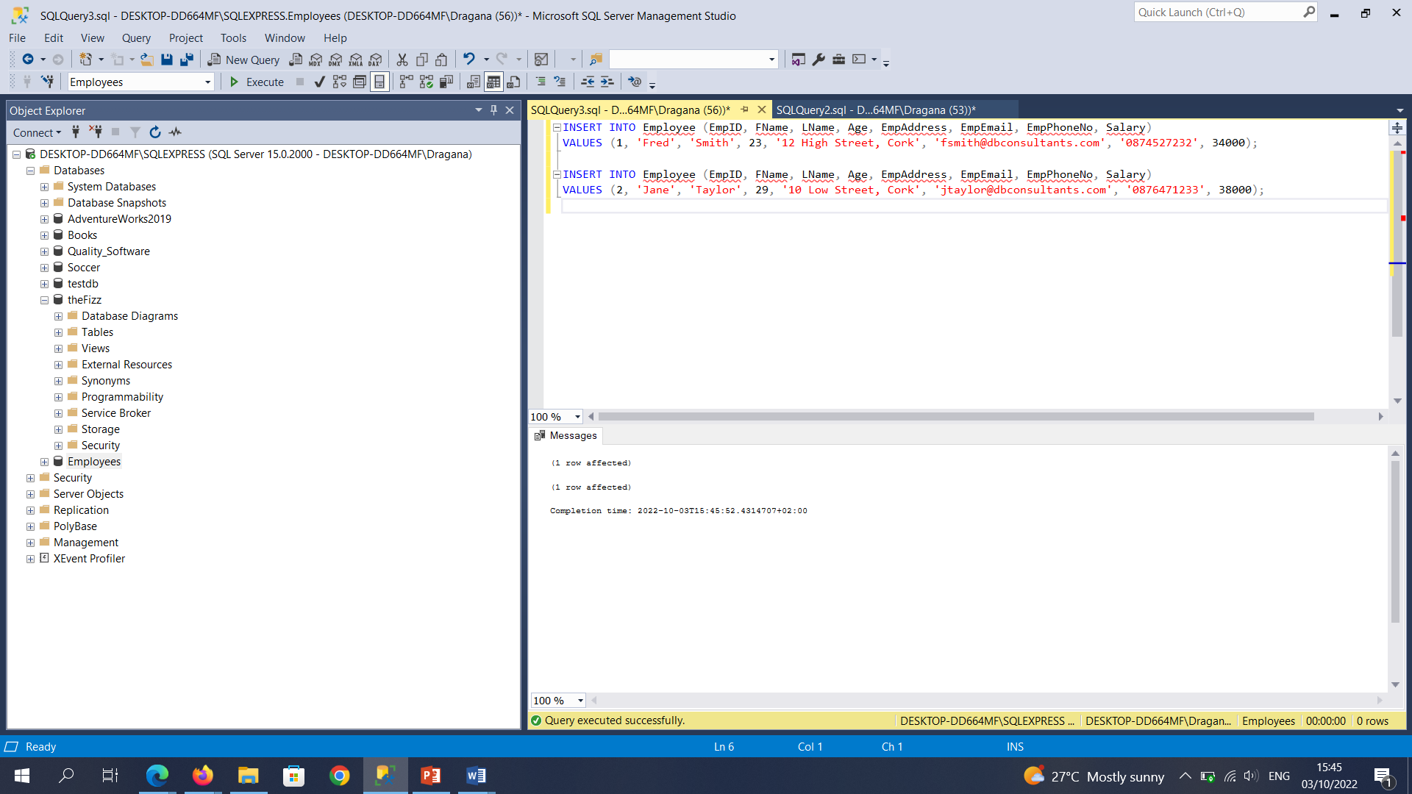

**Part D:**• Create a View named EMPLOYEES_VIEW, which selects all records from the Employee table.

CREATE VIEW EMPLOYEES_VIEW AS

SELECT

EmpID,

FName,

LName,

Age,

EmpAddress,

EmpEmail,

EmpPhoneNo,

Salary

FROM Employees.dbo.Employee;

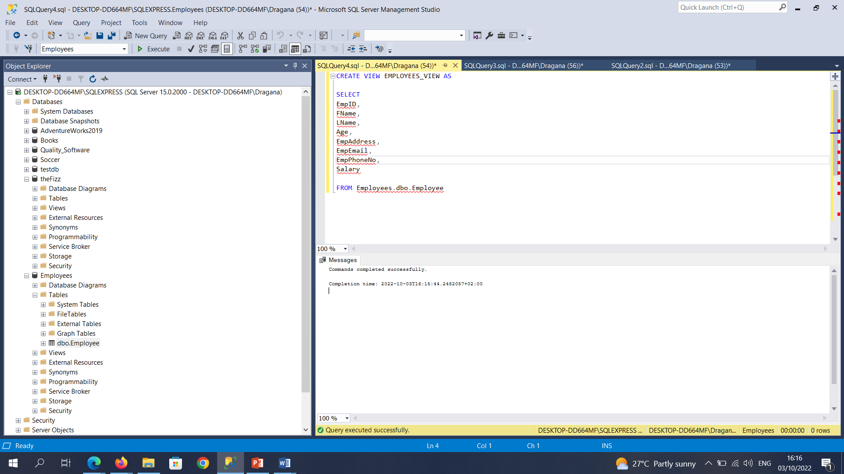

**Part E:**• Query the view.

SELECT* FROM EMPLOYEES_VIEW;

